Assignment Problems: Day 7

The following problems require access to the file named ‘Dataset_Day7.csv’, provided with this assignment. (Use Random State = 203)
The datasets include data from 768 women with several medical predictor variables and one target variable(‘Outcome’). The classification goal is to predict whether or not the patients in the dataset have diabetes or not.
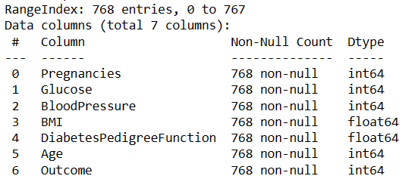
For columns:
Glucose,
BloodPressure,
BMI,
DiabetesPedigreeFunction
If the column value is 0, then they should be considered as missing data.
Problems to solve –
- Firstly, replace all Missing values with relevant figures.
- Then remove all existing outliers and get the final data for classification.
- Split the data into 70% training and 30% testing data. Then, create a logistic regression model with target variable as ‘Outcome’.
  - Print the default model performance metrics: Accuracy, Precision, Recall, F1Score & AIC
- Plot a F1_score vs threshold curve. Find the threshold for which f1-score is the highest.

